A

Major-Project

**“Online Second Hand Books Website”**

**Project Report of subject**

# “Capstone Project Planning [22058]”

## Submitted by

|  |  |  |
| --- | --- | --- |
| **Sr. No** | **Enrollment No.** | **Name of the student** |
| 1 | 1700100270 | Shaikh Swaleha Muniruddin |
| 2 | 1700100274 | Nande Anushka Hanmant |
| 3 | 1800100390 | Tele Snehal Tukaram |
| 4 | 1800100391 | Gatkal Shruti Vishnu |



**Under the guidance of** Mrs. Korade L.S.

Department of Computer Engineering Government Polytechnic, Karad.



**Maharashtra State Board of Technical Education**

**Certificate**

This is to certify that,

|  |  |  |
| --- | --- | --- |
| **Sr. No** | **Enrollment No** | **Name of the student** |
| 1 | 1700100270 | Miss. Shaikh Swaleha Muniruddin |
| 2 | 1700100274 | Miss. Nande Anushka Hanmant |
| 3 | 1800100390 | Miss. Tele Snehal Tukaram |
| 4 | 1800100391 | Miss. Gatkal Shruti Vishnu |

From **Government Polytechnic, Karad** (Code **0010**) have completed **Semester V Project Report** having title **Online Second Hand Books Website** in a group consisting of **4** persons under the guidance of **Mrs. L. S. Korade**

Place: **Karad**

Date: 07/10/2019

**Guide Head of Department Principal**

**Mrs. Korade L. S. Mrs. Korade L. S. Dr. Patil R. K.**



## Acknowledgement

We take it is an opportunity to thank all those who have directly and indirectly inspired, directed and assisted us towards successful completion of this project report.

We express our sincere thanks to the Principal, Dr. Prof. R. K. Patil & the Head of Department, Mrs. L. S. Korade for having us allowed to submit this report as part of our academics learning.

We express our sincere thanks to Mrs. L. S. Korade mam Lecturer in Computer Engineering, Department of Computer Engineering , Govt. Polytechnic Karad for encouragement throughout the project report and guideline in designing & working out this project.

We are also grateful to team of project named as “**Online Second Hand Books Website**” for their highly encouraging and co-operative attitude. We express our sense of gratitude towards our friend and parents for their constant moral support during project report.

Place: Govt. Polytechnic, Karad

Date: 07/10/2019

Yours Sincerely,

Shaikh Swaleha Muniruddin [2208]

Nande Anushka Hanmant [2211]

Tele Snehal Tukaram [2259]

Gatkal Shruti Vishnu [2260]

## Abstract

Students have many course based literature textbooks that they have stopped reading and these books are laying on the book shelves unused. These books can be sold and the proceeds can be used to buy another book the student currently needs.

This website will not only serve students but can also serve the entire population or anybody who wants to buy second hand books and want to empty their book shelves and make financial gain from it. These books can just be simply being uploaded to the website and another student or person can have access to buy the book by just visiting the website.

Students also have lesser incomes compared to the rest of the working population. Hence, any reasonable resource for getting income is always welcomed. All these will be achieved by creating a user friendly complete online shopping system for buying and selling second hand books.

This project deals with developing an e-commerce website for online book sale. It provides the user with catalogue of different books available for purchase in the store. In order to facilitate online purchase a shopping cart is provided to the user.

**Table of Contents**

|  |  |  |  |
| --- | --- | --- | --- |
| **Chapter** | **Content Name** | | **Page No.** |
| **Chapter 1:** | **Introduction and Background of Industry** | | 7-7 |
| 1.1 | Introduction | | 7 |
| 1.2 | Problem Definition | | 7 |
| **Chapter 2:** | **Literature survey for Problem Identification** | | 8-9 |
| 2.1 | Literature Survey | | 8 |
| 2.2 | Proposed Methodology for identified problems. | | 8 |
| 2.3 | Resource and Consumable Requirements | | 9 |
| **Chapter 3:** | **Proposed Detailed Methodology** | | 9-18 |
| 3.1 | Detailed Methodology for Solving Identified Problems. | | 9 |
|  | 3.1.1 | Admin Module | 9 |
|  | 3.1.2 | Member Login Module | 10 |
|  | 3.1.3 | Registration Module | 10 |
|  | 3.1.4 | Seller Module | 10 |
|  | 3.1.5 | Buyer Module | 11 |
|  | 3.1.6 | Search Module | 11 |
|  | 3.1.7 | Shopping Module | 11 |
|  | 3.1.8 | Payment Module | 11 |
| 3.2 | Action Plan | | 12 |
| 3.3 | UMLs | | 13-17 |
|  | 3.3.1 | Use Case Diagram | 13 |
|  | 3.3.2 | Activity Diagram | 14 |
|  | 3.3.3 | Data Flow Diagram | 15 |
|  | 3.3.4 | Gantt Chart | 17 |
|  | Reference and Bibliography | | 18 |

**Figures:**

|  |  |  |
| --- | --- | --- |
| **Figure. No.** | **Figure Name** | **Page No.** |
| 1.1 | Use Case Diagram | 13 |
| 1.2 | Activity Diagram | 14 |
| 1.3 | 0th level DFD | 15 |
| 1.4 | 1st Level DFD | 15 |
| 1.5 | 2nd Level DFD | 16 |
| 1.6 | Gantt Chart | 17 |

### Chapter 1: Introduction and Background of Industry

**1.1. Introduction:**

Online used books portal is an innovative way to help customers lower their education and entertainment costs by buying and selling used books. Customers can buy or sell books through the website‟s combination of e-commerce platform as well as an e-classified system. The service aims to offer used books to students at the least price.

Peoples are comfortable with reading old books. Our idea revolves around providing all such people who would like to read their favorite titles in second hand or old used books, and online portal where they can order books. We also plan to create a library of these second hand books which can be borrowed and then returned after a specified period of time.

Second hand books constitute a major portion of the book retail market. The size of the Indian book retail industry is pegged at Rs.3000 crore of which organized book retail constitutes only 7%. The industry is expected to grow by approximately 15% a year. Our platform will provide an opportunity to people who normally buy new books but would like to sell them after they have read them. This makes the small contribution in the achieving goal of the industries

**1.2. Problem definition:**

An academic syllabus change year by year so, students majorly require new books according to their syllabus but problem is what to do with old books? Some students cannot afford to buy new books yearly. Some peoples are not regular in reading books because of they can‟t afford the buying new books. Sometimes rare books are not available in the nearby area. So there is high need of one platform which provides a service of buying and selling old books.

Since the idea is to sell used old books, some customers might be apprehensive about the quality of books but this idea is very useful for the actual needy persons. The second hand books buying and selling system will provide all the above services to users. For sellers who go to sell their used books, they have to face some problems like costumer‟s negotiation when dealing face to face. The chances for them to find possible buyer are also small. This problem can be overcome by using this system.

This project is like an e-bookstore website. An online second hand book buying and selling system is a virtual store on internet where customers can buy an old books and also sell their old books.

### Chapter 2: Literature survey for Problem Identification

**2.1. Literature Survey:**

1. www.pustakkosh.com

This website allow to buy or rent books, buy and sell second hand books. Design and different modules of this website are considered for the website designs are referred.

1. www.bookchore.com

This website is about buying and selling books which provide facility to search the book we want. Buying and selling modules of this website are referred.

1. „e-Bookstore: Opening Door to garden of Knowledge‟ (International Islamic

University Malaysia, 6 June 2017)

Second hand book shopping has been current trend in today‟s stream. The process of selling and buying the second hand book is somehow leaded to time and energy wastage. The purpose of this paper is to give solution through online second hand book shop system. The customer segment includes buyer and seller. This project has proposed conceptual solutions through Business Model Canvas (BMC), Value Proposition Canvas (VPC) and Environment Map (EM).

This paper is help to review that what has been already established regarding to this project by accredited researches.

* 1. **Proposed methodology for identified Problem:**

Initiation of this project starts with gathering all of the necessary requirements from lecturers and students in order to produce a website which is feasible to be maintained and meet user requirements. In order to know the problem faced by buyer and seller of old books, firstly we are try to gaining all information for the project. We use this information to know the problem and benefits that should be provided by this system. This is done to know the what are the criteria that fit into customers need.

Based on literature survey as well as data collection, the prototype of the system was developed. Construction of the prototype was modified according to the feedback of the end users. The prototype which results from the design phase is then evaluated by the students and the evaluation results can be used to refine the requirements for the software to be developed. Iteration occurs as the prototype will be refine to satisfy the user requirements, while at the same time enabling the developer to better understand what needs to be done.

* 1. **Resources and Consumable Required:**

|  |  |  |  |  |
| --- | --- | --- | --- | --- |
| **Sr.**  **No** | **Name of**  **Resource** | **Specification** | **Quantity** | **Remark** |
| 1. | Laptop | Intel(R)Core(TM)i3-7020U CPU  @ 2.30GHz | 1 |  |
| 2. | Software | Visual studio code, Browser,  Selenium | 1 Each |  |
| 3 | Operating system | Windows 10 | 1 |  |

### Chapter 3: Proposed Detailed Methodology

**3.1. Detailed Methodology for solving identified problem:**

3.1.1. Admin Module:

Admin will use this application to give them access to the person who wants to purchase books and make a contribution by selling old books, the even admin will add new data regarding books so that the user can easily access it and purchase the books on demand.

*Specifications:*

1. Admin can approve the request who want to purchase or sell the book.
2. Admin have all authorities regarding the seller and buyer details and their existence in the system.
3. Admin can check the feedbacks of the buyer.

3.1.2. Member Login Module:

This option of the system will help the user to get a login and check the notifications if any wants to sell the book or wants to purchase the book to the buyer and seller respectively.

*Specifications:*

1. In this module if the new user wants to use this system then, create new user account option will be enabled for him/her.
2. If the user has its account already then he/she can login into the system by his/her valid username and password.
3. Log in and log out functionality will be provided.
4. User can change and create new password.

3.1.3. Registration Module:

This option will be enabled only for those users who are new in the system and wants to part of the system.

*Specifications:*

1. In this module the new user will be able to create new account by filling the registration form.
2. User has an ability to make new username and password according to his/her choice.
3. User profile will be created.

3.1.4. Seller Module:

In this module all the seller details are stored and the seller can upload his/her books for selling.

*Specifications:*

1. Seller has an ability to check the feedback of the buyer regarding his/her book.
2. Seller can upload books and delete their own books uploaded.
3. Seller knows the status of their books uploaded.
4. Seller can get notification if any buyer wants to purchase the book uploaded by him/her.

3.1.5. Buyer Module:

In this module all the details of buyer will be stored and the buyer can check the books according to his/her requirements.

*Specifications:*

1. Buyer can get the notification regarding the book that he/she wants to purchase but at current time the book is not available.
2. Buyer can check his/her history regarding the purchase of the books.

3.1.6. Search Module:

Search for books using their ISBN numbers or book titles. Enter title or ISBN number in the text box and a feedback is sent back to the current user on the status of the search after the button search is clicked.

*Specifications:*

1. On click of the book results shows you detail description of the book in another page.
2. The status of the book which is searched is also displayed to the buyer or user.

3.1.7. Shopping Module:

The actual shopping process is handled by cart items and book shopping cart. The book shopping cart manages the books in the cart and handles the shopping basket.

*Specifications:*

1. Shopping cart that is visible at all times and maintains its status.
2. Delete and update book from shopping cart.
3. A page to show the items shopped made by the user showing shipping and location details.

3.1.8. Payment Module:

Considering the fact that the website is small for now and to make it easy for people to trust the website by giving out their credit card numbers and actually buy books on this website we will outsource financial handling to trusted and well known online payment service called as Net Banking.

*Specifications:*

1. Buyer pays to website account.
2. Buyer gets feedback about the process.
3. Seller gets informed that account is credited.

* 1. **Action Plan:**

|  |  |  |  |  |
| --- | --- | --- | --- | --- |
| **Sr. No** | **Details of activity** | **Planned start date** | **Planned**  **Finish date** | **Name of Responsible Team Members** |
| 1. | Select project topics. | 2/07/2019 | 9/07/2019 | All members |
| 2. | Prepare the plan | 9/07/2019 | 16/07/2019 | All members |
| 3. | Decide project | 30/07/2019 | 13/08/2019 | All members |
| 4. | Prepare proposal of project | 13/08/2019 | 27/08/2019 | All members |
| 5. | Collect the requirement of the project. | 27/08/2019 | 3/09/2019 | Gatkal Shruti Vishnu Tele Snehal Tukaram |
| 6. | Classify requirements in their types. (Functional, non-functional). | 3/09/2019 | 6/09/2019 | Shaikh Swaleha Muniruddin Nande Anushka Hanmant |
| 7. | Develop use case diagram. | 6/09/2019 | 10/09/201 | Nande Anushka Hanmant  Tele Snehal Tukaram |
| 8. | Decide the languages used to develop the project. | 10/09/2019 | 13/09/2.019 | Shaikh Swaleha Muniruddin  Gatkal Shruti Visshnu |
| 9. | Identify the risks that are produced. | 13/09/2019 | 17/09/2019 | All members |
| 10. | Define the function that software performs. | 17/09/2019 | 20/09/2019 | Shaikh Swaleha Muniruddin Tele Snehal Tukaram |
| 11. | Represent behavior of software. | 21/09/2019 | 23/09/2019 | Gatkal Shruti Vishnu  Nande Anushka Hanmant |
| 12. | Develop data flow diagram. | 24/09/2019 | 27/09/2019 | Shaikh Swaleha Muniruddin Nande Anushka Hanmant |
| 13. | Develop Structure flowcharts and decision tables. | 28/09/2019 | 1/10/2019 | Gatkal Shruti Vishnu Tele Snehal Tukaram |

* 1. **UMLs:**
     1. Use Case Diagram:

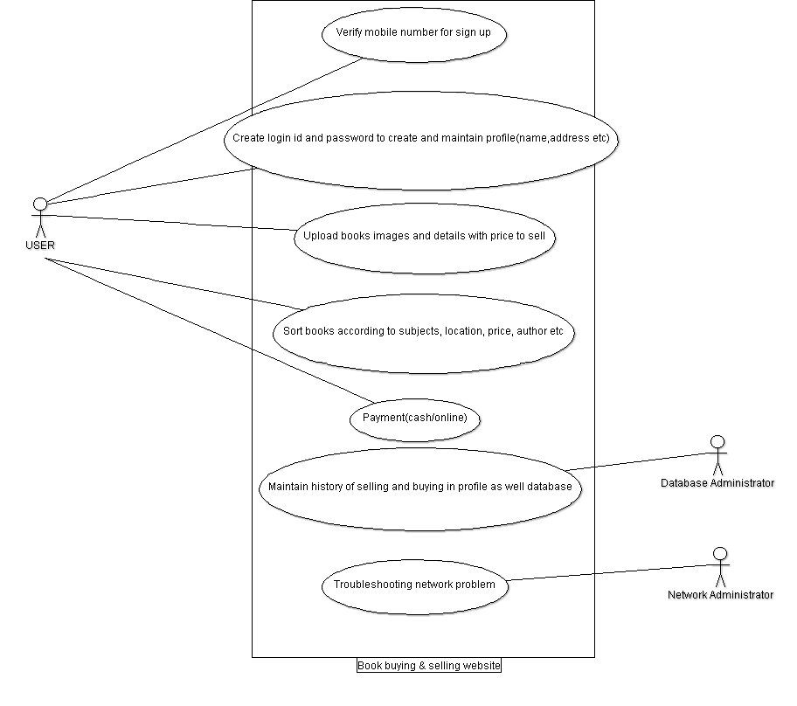

Fig. 1.1 Use Case Diagram

* + 1. Activity Diagram:

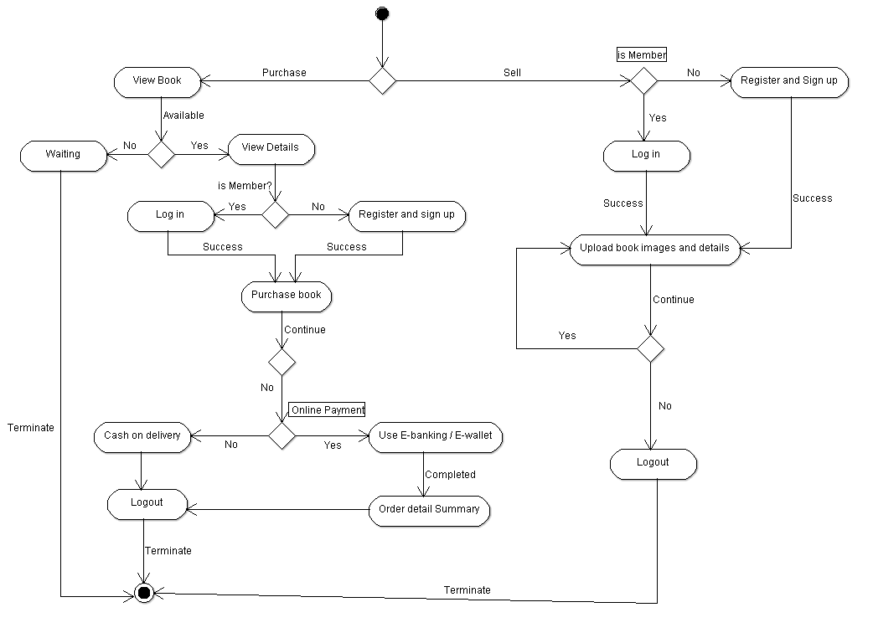

Fig. 1.2 Activity Diagram

* + 1. Data Flow Diagram:

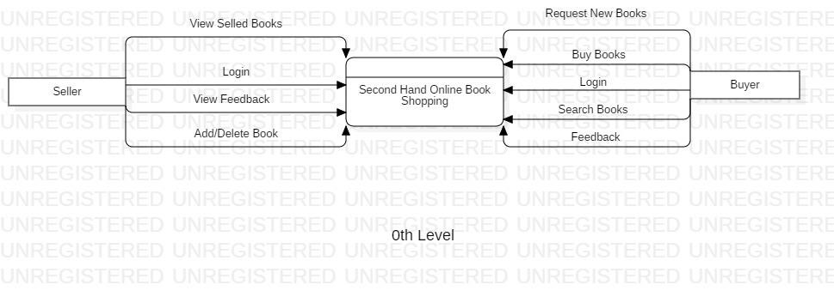

Fig. 1.3 0th Level DFD

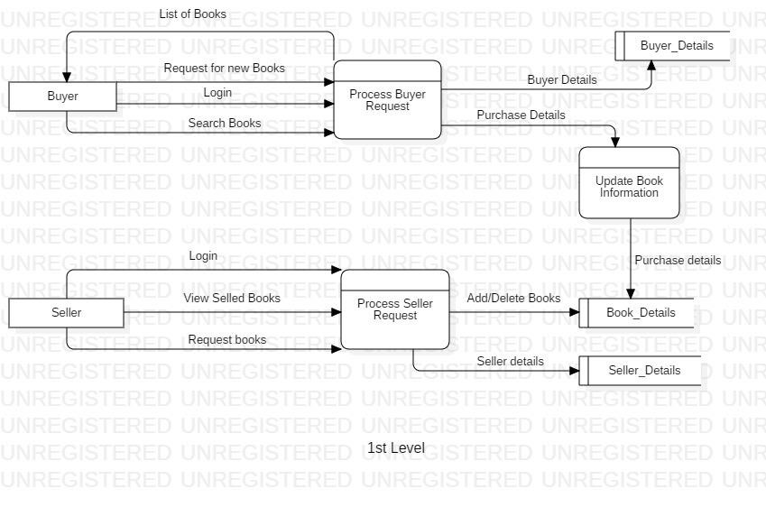

Fig. 1.4 1st Level DFD

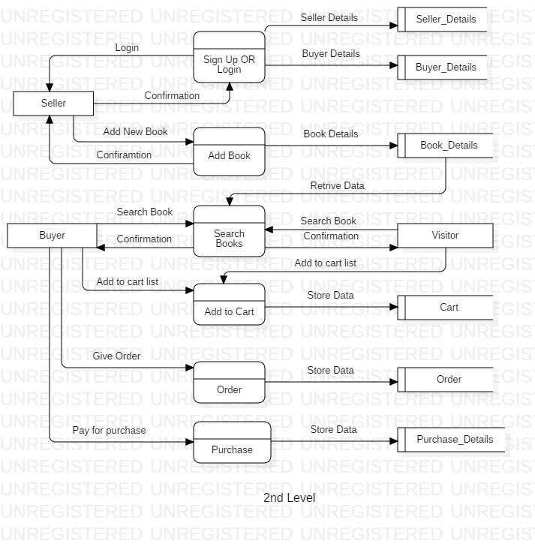

Fig. 1.5 2nd Level DFD

* + 1. Gantt Chart:

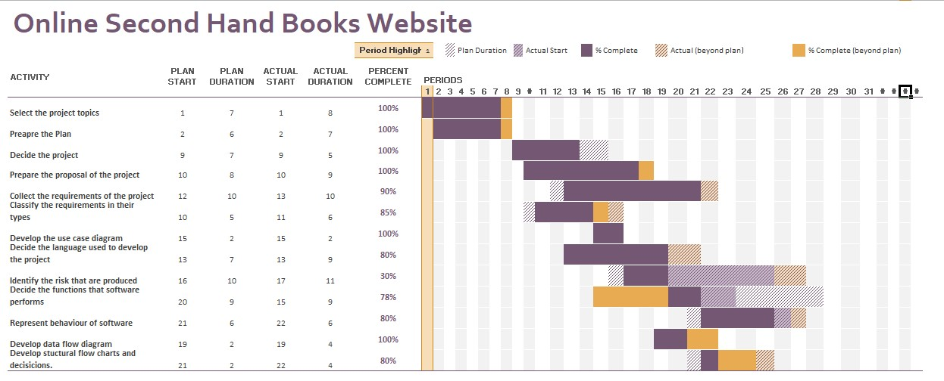

Fig. 1.6 Gantt Chart

**References and Bibliography**

1. A. K (2013, January 17). Second shand textbooks-Basics and advantages. Retrieved from https://college-college-life.knoji.com/second-hands-textbooks-basics-andadvantages-2/
2. Noren, E. (2013, July 9). Analysis of Amazon Business Model. Retrieved from https://www.digitalbusinessmodelguru.com/2013/07/analysis-of-amazon-businessmodel.html
3. The Pros and Cons of shopping for Books in Bookstores vs. Online. (2016, February 18). Retrieved from https://www.bookmasters.com/blog/shopping-books-bookstoresonline